Операционные системы и виртуализация (Linux)  
1. Использование команды cat в Linux.  
***mkdir finish_test***

***cd finish_test/***

***cat > Pets.txt***

***cat > Pack_animals.txt***

***cat Pets.txt***

***cat Pack_animals.txt***

***cat Pets.txt Pack_animals.txt > Human_friends.txt***

***cat Human_friends.txt***

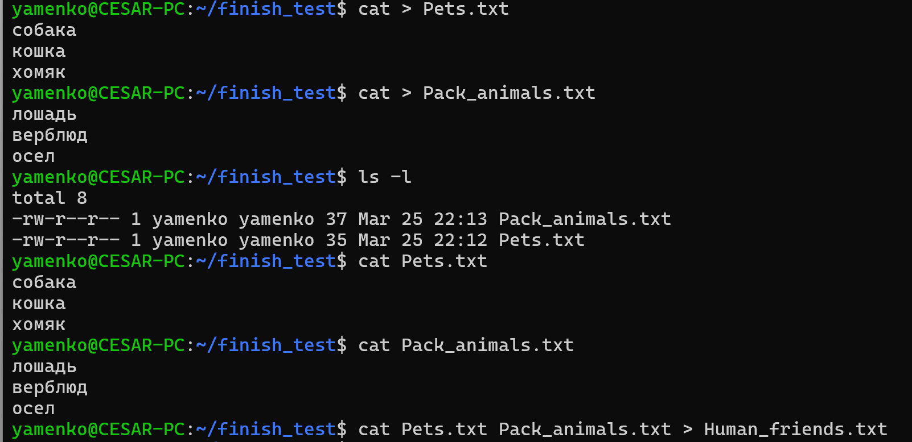

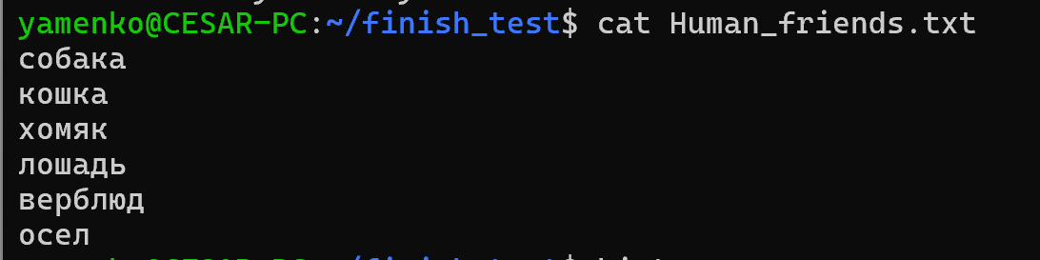

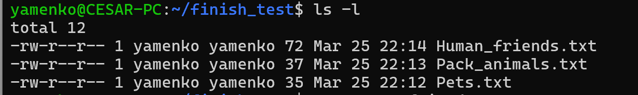

## 2. Работа с директориями в Linux.

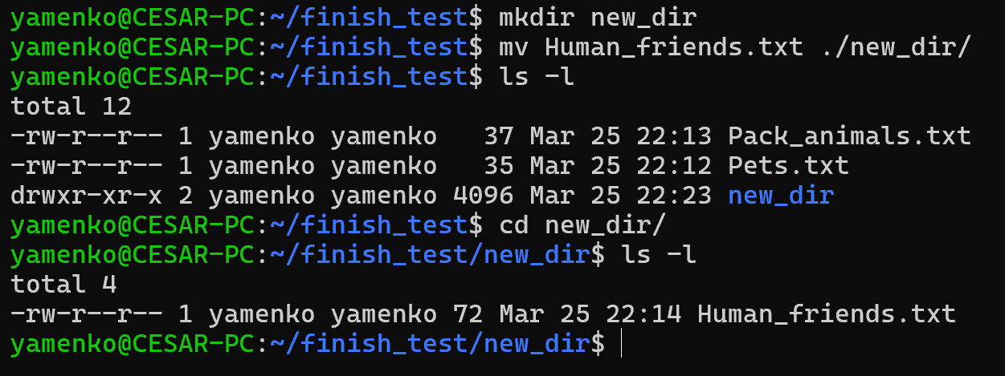

3. Работа с MySQL в Linux. “Установить MySQL на вашу вычислительную машину”

***curl -fsSL http://repo.mysql.com/RPM-GPG-KEY-mysql-2022 | sudo gpg --dearmor | sudo tee /usr/share/keyrings/mysql.gpg > /dev/null***

***echo "deb [arch=$(dpkg --print-architecture) signed-by=/usr/share/keyrings/mysql.gpg] http://repo.mysql.com/apt/ubuntu $(lsb_release -cs) mysql-8.0" | sudo tee -a /etc/apt/sources.list.d/mysql.list***

***sudo apt update***

***sudo apt install mysql-community-server***

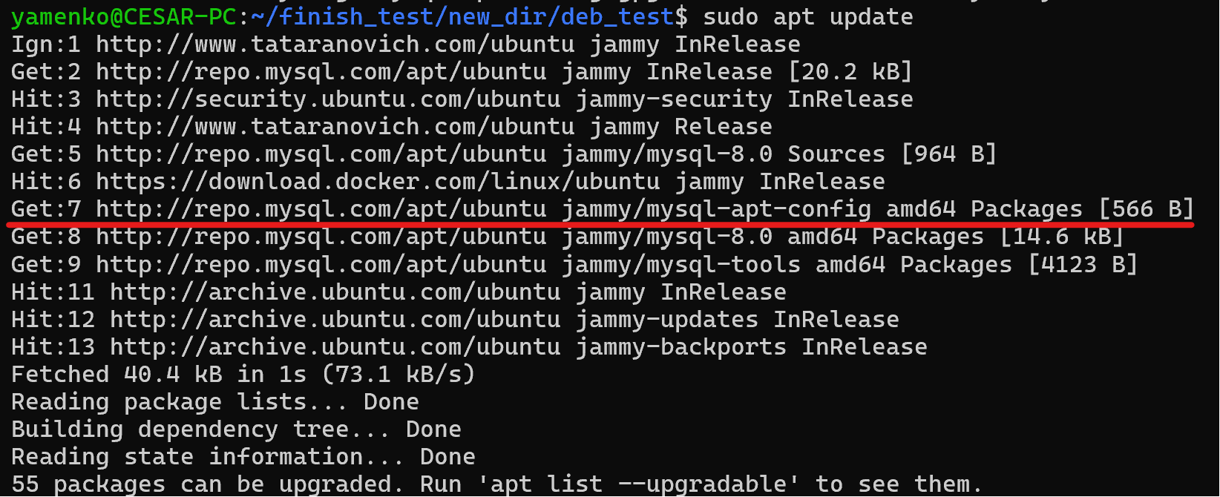

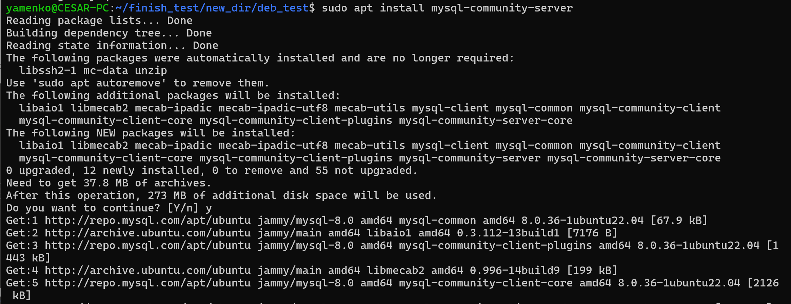

## 4. Управление deb-пакетами

***wget*** [***https://dev.mysql.com/get/mysql-apt-config_0.8.29-1_all.deb***](https://dev.mysql.com/get/mysql-apt-config_0.8.29-1_all.deb)

***sudo dpkg -i mc_3%3a4.8.31-1_amd64.deb***

***sudo dpkg -r mc***





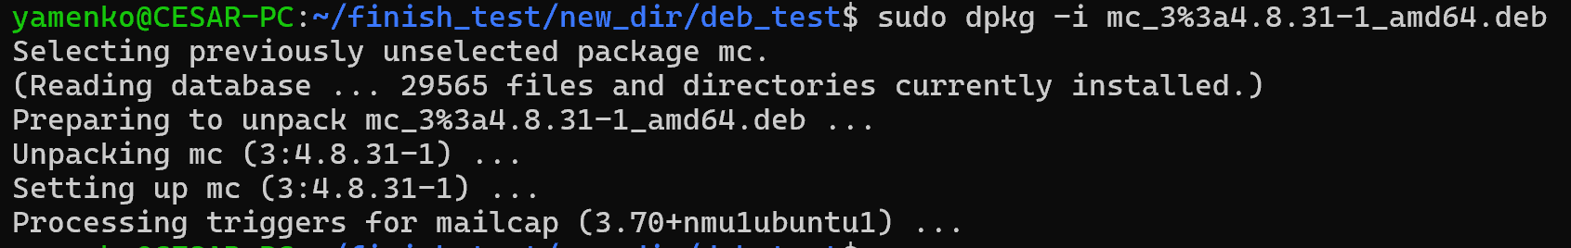

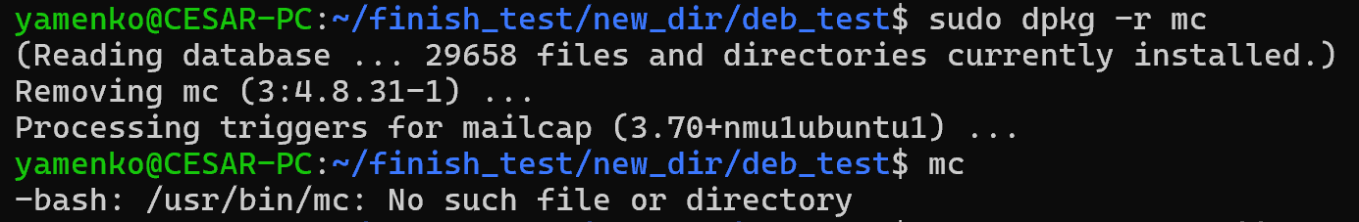

## 5. История команд в терминале Ubuntu

483 ls -l

484 mkdir finish_test

485 cd finish_test/

486 cat > Pets.txt

487 cat > Pack_animals.txt

488 ls -l

489 cat Pets.txt

490 cat Pack_animals.txt

491 cat Pets.txt Pack_animals.txt > Human_friends.txt

492 ls -l

493 cat Human_friends.txt

494 history

495 cls

496 clear

497 mkdir new_dir

498 mv Human_friends.txt ./new_dir/

499 ls -l

500 cd new_dir/

501 ls -l

502 mkdir deb_test

503 cd deb_test/

504 wget https://ftp.midnight-commander.org/mc-4.8.31.tar.xz

505 sudo wget https://ftp.midnight-commander.org/mc-4.8.31.tar.xz

506 clesr

507 clear

508 curl -fsSL https://www.tataranovich.com/debian/gpg | sudo apt-key add -

509 apt-add-repository 'deb http://www.tataranovich.com/ubuntu jammy main'

510 sudo apt-add-repository 'deb http://www.tataranovich.com/ubuntu jammy main'

511 apt update

512 sudo apt update

513 apt search mc

514 sudo apt install mc

515 sudo apt download mc

516 wget https://dev.mysql.com/get/mysql-apt-config_0.8.29-1_all.deb

517 dpkg -i mysql-apt-config_0.8.29-1_all.deb

518 sudo dpkg -i mysql-apt-config_0.8.29-1_all.deb

519 mysql

520 sudo dpkg -i mysql-apt-config_0.8.29-1_all.deb

521 ls -l

522 sudo dpkg -i mc_3%3a4.8.31-1_amd64.deb

523 mc

524 sudo apt remove mc

525 sudo dpkg -i mc_3%3a4.8.31-1_amd64.deb

526 mc

527 sudo dpkg -r mc_3%3a4.8.31-1_amd64.deb

528 sudo dpkg -r mc

529 mc

530 curl -fsSL http://repo.mysql.com/RPM-GPG-KEY-mysql-2022 | sudo gpg --dearmor | sudo tee /usr/share/keyrings/mysql.gpg > /dev/null

531 echo "deb [arch=$(dpkg --print-architecture) signed-by=/usr/share/keyrings/mysql.gpg] http://repo.mysql.com/apt/ubuntu $(lsb_release -cs) mysql-8.0" | sudo tee -a /etc/apt/sources.list.d/mysql.list

532 grep mysql /etc/apt/sources.list.d/mysql.list

533 sudo apt update

534 sudo dpkg-reconfigure mysql-apt-config

535 sudo apt update

536 sudo apt install mysql

537 sudo apt install mysql-community-server

538 mysql

539 ls -l

540 mysql_config_editor

541 history